SoA Final Test Exam

Project Overview
We are developing an internal web-based Pet Clinic application that enables clinic staff to manage client (owner) accounts and schedule clinical visits for their pets. To book a visit, the pet’s information must already exist in the system.
The application is accessible only to clinic personnel, within the clinic’s internal network, and does not require login functionality.
All core functionalities are implemented, but they have not undergone comprehensive testing. We are seeking high-quality testing services to validate that the requirements have been correctly implemented.
The development process follows a Scrum-based lifecycle, and future iterations are planned. We also aim to establish an automation testing strategy to support regression testing.

Environment Setup
- Start the application using Docker:
docker run -p 8080:8080 springcommunity/spring-framework-petclinic
- Test environment: http://localhost:8080
- Supported browser: Chrome (Firefox and Edge support planned)

User Stories and Acceptance Criteria

1. Owner Registration
User Story:
As a system user, I want to register an owner so that the system can maintain a record of clinic clients.
Find Owners > Add Owner
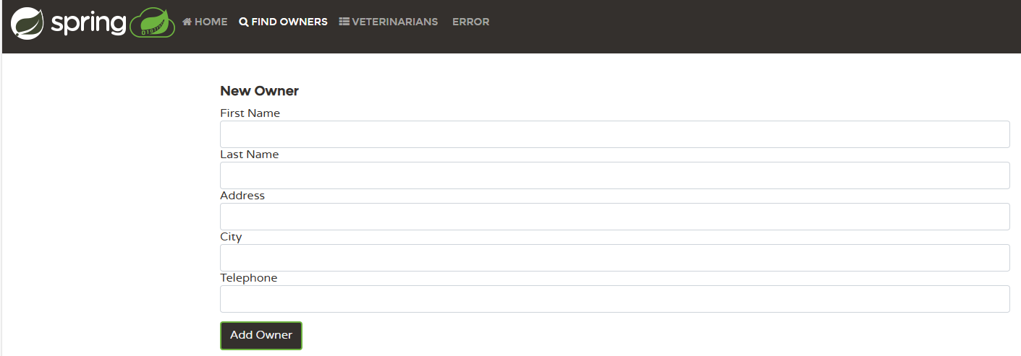
Acceptance Criteria:
- All fields are mandatory.
- Field validation rules:
  - First Name, Last Name, City: English alphabet only, minimum 2 characters.
  - Address: English letters, numbers, and special characters allowed.
  - Telephone: Digits only, maximum 10 digits.
- On successful registration:
  - The owner is created and displayed correctly in a table.
- On failure:
  - The system provides clear warning and error details.

2. Add Pet to Owner
User Story:
As a system user, I want to add pets to owners so the system can associate each pet with its respective owner.
Find Owners > Find Owner (empty search) > Select an Owner > Click Add New Pet
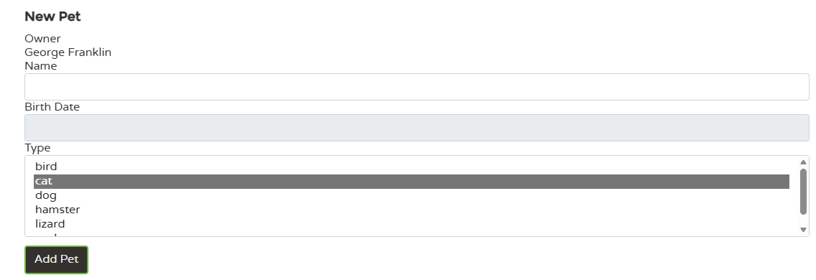
Acceptance Criteria:
- The Add New Pet button in an owner’s information page opens the pet registration form.
- The form displays the owner’s name.
- All fields are required.
- Only one pet type can be selected from the available list.
- Name may contain English letters and numbers.
- Birthdate cannot be in the future.
- On success:
  - The owner’s information page is updated with pet details.
- On failure:
  - The system displays a warning describing the issue.
- Multiple pets can be added for a single owner.

3. Book a Visit for a Pet
User Story:
As a system user, I want to add visits for pets so that the system can log visits and assign veterinarians.
Find Owners > Find Owner (empty search) > Select an Owner > Click Add Visit
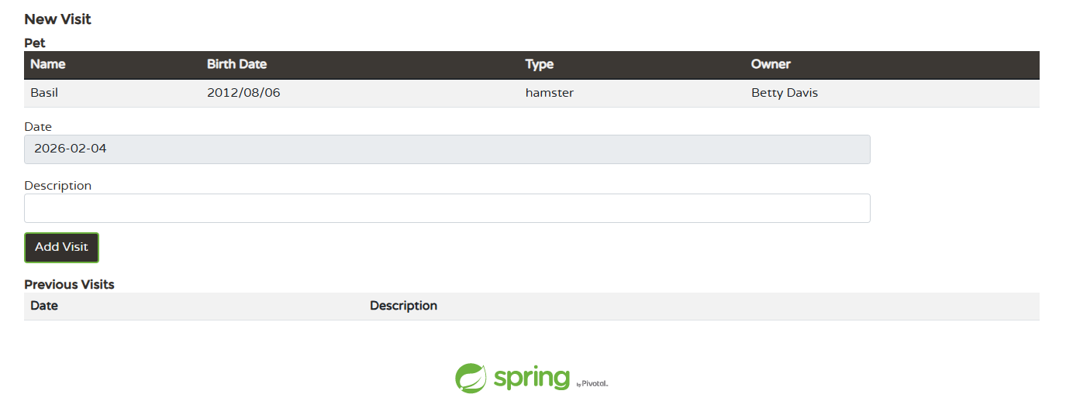
Acceptance Criteria:
- Each pet on an owner’s information page has an Add Visit link.
- The link opens the visit booking form.
- The visit page displays pet information: name, birthdate, type, and owner name.
- All fields are mandatory.
- Date: Cannot be earlier than the current date.
- Description: Allows letters, numbers, and special characters.
- On success:
  - The owner information page is updated with all visit details.
- On failure:
  - The system displays a warning describing the problem.
- A pet may have multiple visits recorded.

Tasks

Manual Testing
- Create test cases covering all user stories.
  - Excel file can be used
- Execute test cases and prepare a test report.
- Log all identified defects appropriately.
  - Same excel file with new tab can be used

Automation Tasks

Selenium WebDriver with .NET
- Select one key (business critical) manual test case for automation from each of the user stories.
- Automate selected cases following test automation best practices.
- (Optional) Extend the automation suite with any extra scenarios you consider valuable.

REST API Automation
- Start the REST service:
docker run -p 9966:9966 springcommunity/spring-petclinic-rest
- Access Swagger UI:
http://localhost:9966/petclinic/swagger-ui.html

Task A — GET /api/owners
Goal: Validate the list of owners is returned correctly.
Requirements (assert at minimum):
- Status 200 and Content-Type: application/json.
- For at least one element, validate core fields are present and non-empty:
  - id,
  - firstName,
  - lastName,
  - address,
  - city,
  - telephone.

Task B — POST /api/owners/{ownerId}/pets
Goal: Create a pet for an existing owner and verify persistence.
Pre-steps:
- From Task A’s response, pick a valid ownerId.
- Fetch a valid pet type via GET /api/pettypes to obtain type.id.
- Request Content-Type: application/json
Request (example):
{
"name": "Leo",
"birthDate": "2010-09-07",
"type": {
"name": "cat",
"id": 1
}
Requirements (assert at minimum):
- Status 201 Created.
- Response JSON contains:
  - non-null id
  - echoes name
  - references a valid type.id.

Submission
After completing the tasks (or once time is up), organize both the manual and automated work into a single ZIP archive and upload it into your personal MS Teams folder.
Important: Remove all compiled/generated files from automation projects before submission.

